Musculoskeletal New Patient History Date:

Patients name: Age: DOB:

Chief Complaint:

When and how did the problem occur?

Was this a result of an acute injury or accident?

Problem Diagram: (Please mark the areas on the diagram where you are experiencing difficulty.)
Leave Blank
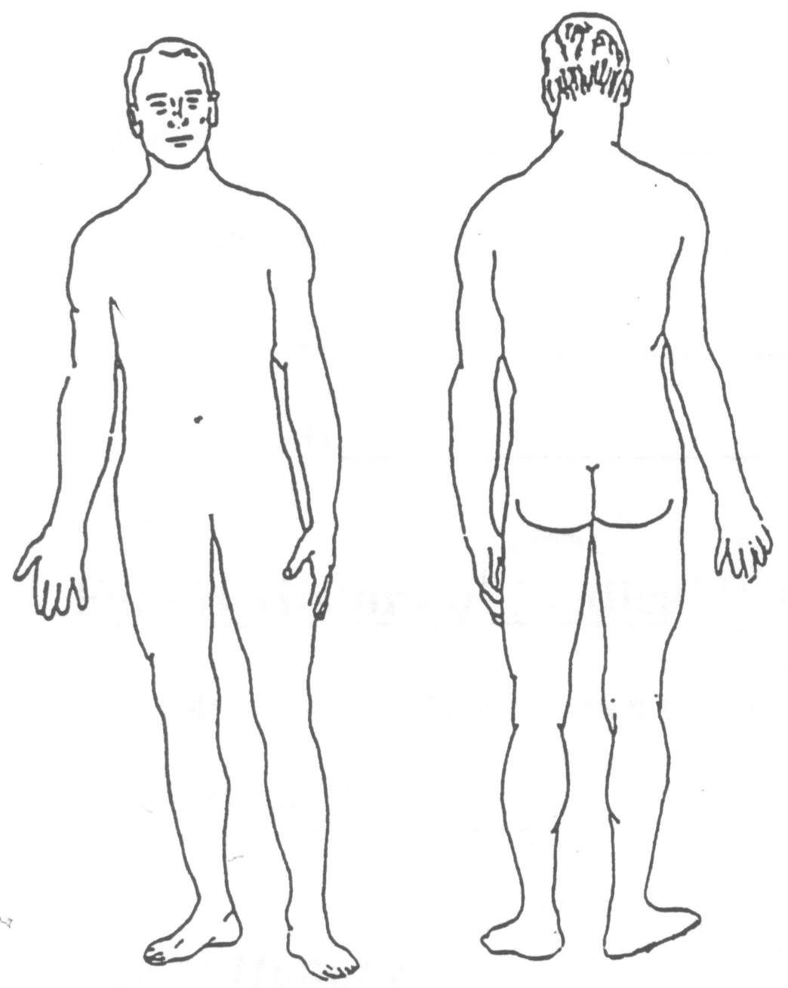

If you have pain please describe the pain sensation. (Circle or highlight those that apply)
Aching Tightness Pins & Needles Burning Stabbing/Sharp
Shooting Twisting Pressure Numbness/Tingling

When during the day do you have your pain?

What makes your pain worse?

What makes your pain better?

What daily activities does this problem affect?

Have you received any special testing or procedures for this problem? (Circle or highlight)

CT Scan MRI EMG X-rays Injections Surgery

Medical Illnesses (that you have been Diagnosed with: circle/highlight those that apply)

Diabetes, Asthma, High Blood Pressure, Heart Attack , Sleep Disorders

Stroke, Stomach Ulcers, Cancer, Heart Murmur, HIV/AIDs, Hepatitis,

Anemia, Seizures, Hyper/Hypo Thyroid, Osteoporosis, Deep Vein Thrombosis,

Osteoarthritis or Rheumatoid Arthritis, Bowel or Bladder Incontinence, Broken Bones

*Other

Injuries:
(Include broken bones, concussion, motor vehicle accidents, falls etc.)

Surgeries: 1) Date:

2) Date:

3) Date:

Family History of Medical Problems: (Circle/highlight those that apply)

Arthritis Back Problems Heart Problems Diabetes Cancer

*Other

Social History

Do you exercise? Yes / No
What type?

How often and how long?

Occupation

Hobbies/Interests

_______________________ __________________________
Therapist Signature Patient Signature

